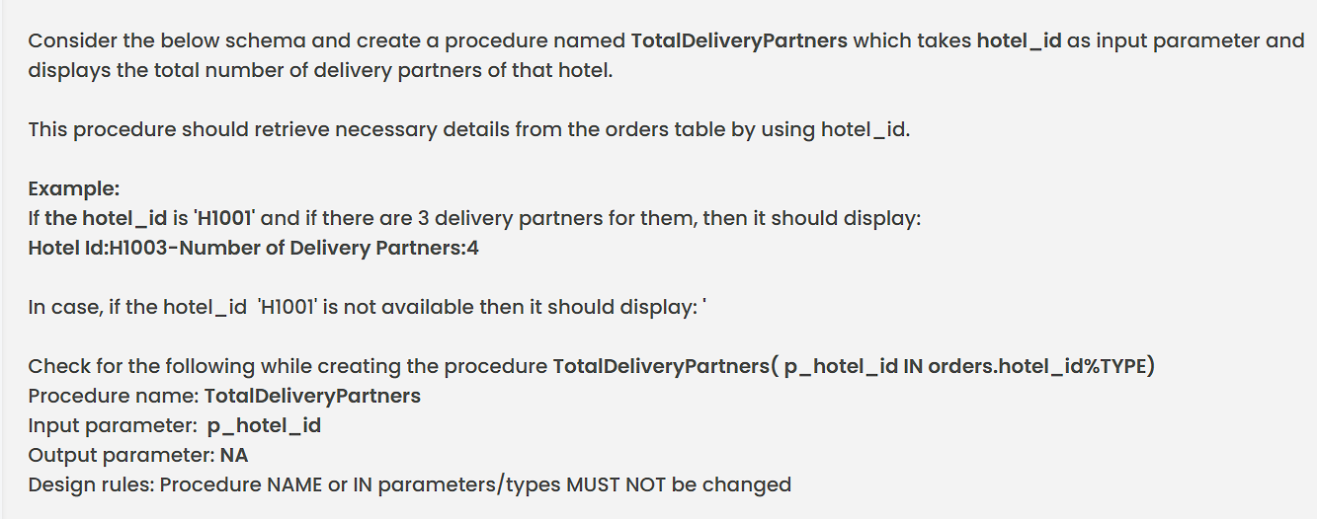

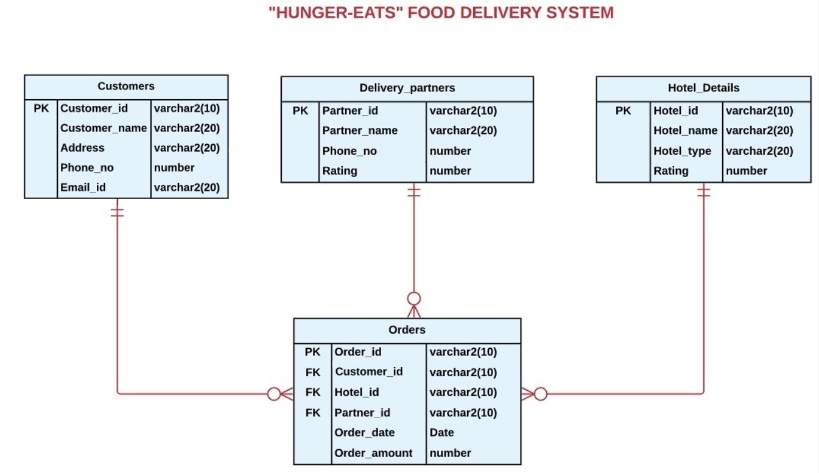

Code (Answer) :

Sample.sql

CREATE PROCEDURE TotalDeliveryPartners(p_hotel_id IN orders.hotel_id%TYPE)
As v_count NUMBER;
BEGIN
SELECT Count(Distinct Partner_id) into v_count
from orders
where hotel_id = p_hotel_id;

if v_count = 0 THEN
DBMS_OUTPUT.PUT_LINE('Invalid Hotel Id');
else
DBMS_OUTPUT.PUT_LINE('Hotel Id:'||p_hotel_id||'-Number of Delivery Partners:'||v_count);
END IF;
END;
/

2. Students Seat Availability

Write a PL/SQL procedure for checking the availability of seats in the college that permits seats only if there are sufficient seats available in the course. If a particular seat required by the student is available in the course, then update the Total_Seats field in the Course table and display the message as 'Seats Available'. If not, display the message 'Seats Not Available'.
The procedure should take the course_name and no_of_seats as input.
Course Table Structure
Course_Name | VARCHAR2(50) | PK
Category | VARCHAR2(20)
Total_Seats | NUMBER
Start_Date | DATE
End_Date | DATE

Sample records:
Course_Name | Category | Total_Seats | Start_Date | End_Date
Agriculture & Forestry | Engineering | 190 | 03-03-2019 | 19-01-2020
Arts, Design & Architecture | Arts & Science | 40 | 08-11-2018 | 27-09-2019
Applied Sciences & Professions | Engineering | 70 | 12-06-2022 | 24-11-2022

Functional Requirement:
Procedure Student_Enrollment(p_coursename varchar, no_of_seats number)
Sample input:
Student_EnrollmentApplied Sciences & Professions, 50);
Sample output:
Seats Available
(Note: The course_name'Applied Sciences & Professions' and no_of_seats:50 are given as inputs for procedure Student_Enrollment. The Total_Seats of that Course_Name is 70 as given in sample records (update the Total_Seats field as 20 (70-50)) and hence message displayed as 'Seats Available'.)

Code Answer :

Sample.sql
create procedure Student_Enrollment(p_coursename varchar, no_of_seats number )
as

numSeats number;
begin
select total_seats into numSeats
from course
where course_name=p_coursename;
if numSeats>=no_of_seats
then
update course
set total_seats=total_seats - no_of_seats
where course_name=p_coursename;
DBMS_OUTPUT.PUT_LINE('Seats Available');
else
DBMS_OUTPUT.PUT_LINE('Seats Not Available');
end if;
end;
/

